

Cognos Reports Export Run Guide

Version 1.0

# 

Table of Contents

1. Introduction 3

1.1 Overview 3

2. Configuring the Property File 3

3. Configuring the Script 4

3.1 Configuring the Script 4

3.2 Execution of the Script 4

1. Introduction
   1. Overview

Script will export all the reports from Cognos automatically in local system.

The operation consists of two parts.

1. Configuring the property file.
2. Run the script to export all the reports.

# 

1. Configuring the property file

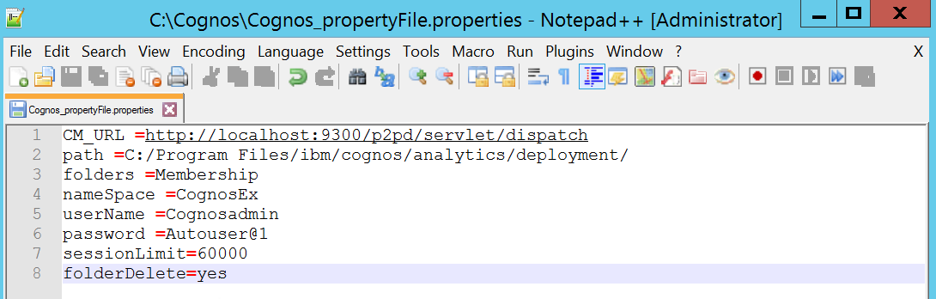

* **CM_URL**: Provide the congos URL path
* **path:** Provide the path where files will get downloaded. Default directory is deployment folder as mentioned above
* **folders:** For bulk export provide (*) and for custom export provide the desired folders separated by comma
* **namespace, username, and password:** Connection details (namespace, username, password) to be provided
* **sessionLimit**: Please provide (10000) in sessionLimit when folders=*, i.e. bulkExport.

For custom export provide based on the file size. For big files (eg: 859MB provide as 60000 or more).

* **folderDelete**: If this is set as yes, it will delete the zip files from deployment folder post completion, if its empty it will keep the zip files.

1. Configuring the Script

* Place the jar, properties file and Cognos.sh file in Linux environment.

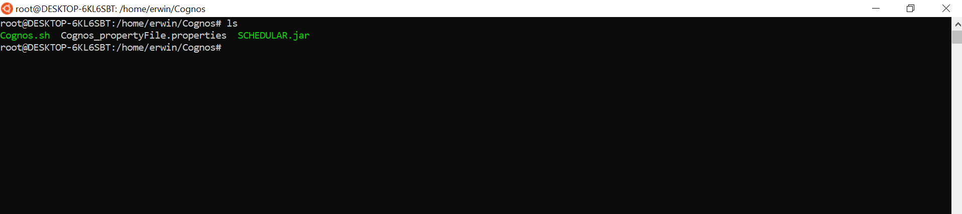

* Edit the script file by providing the property file path and save it.

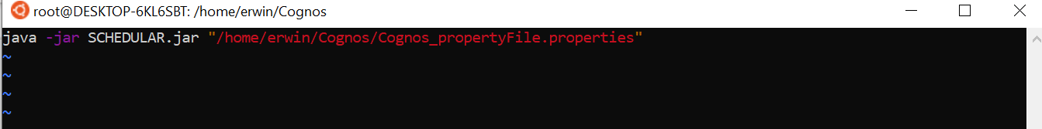

* 1. Execution of the Script

Running the Cognos.sh file which will create directory named ‘Erwin’ in Cognos Deployment Environment which will create additional sub directories as below.

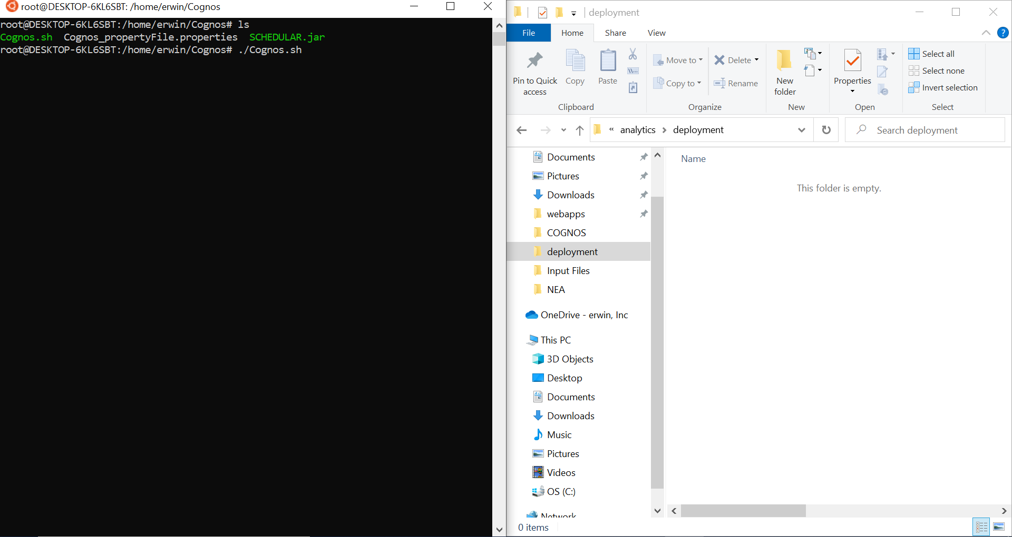

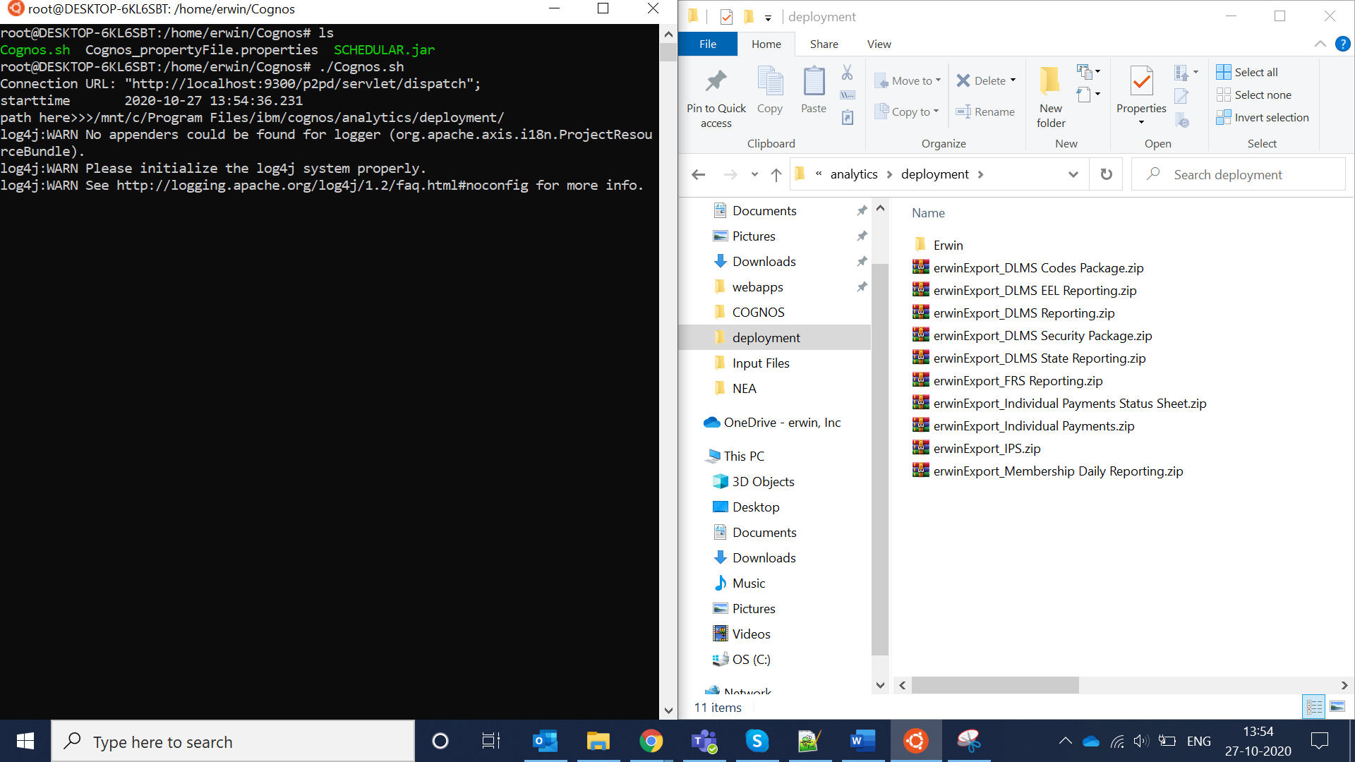

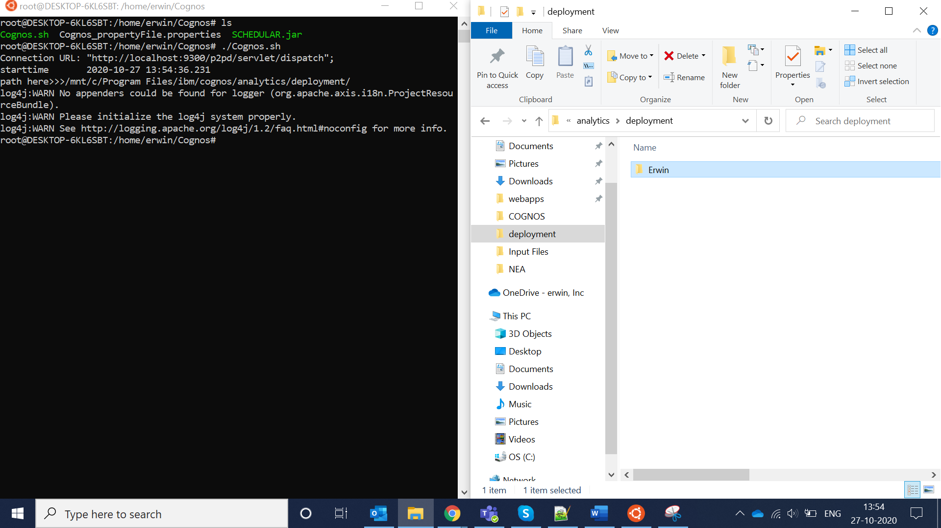

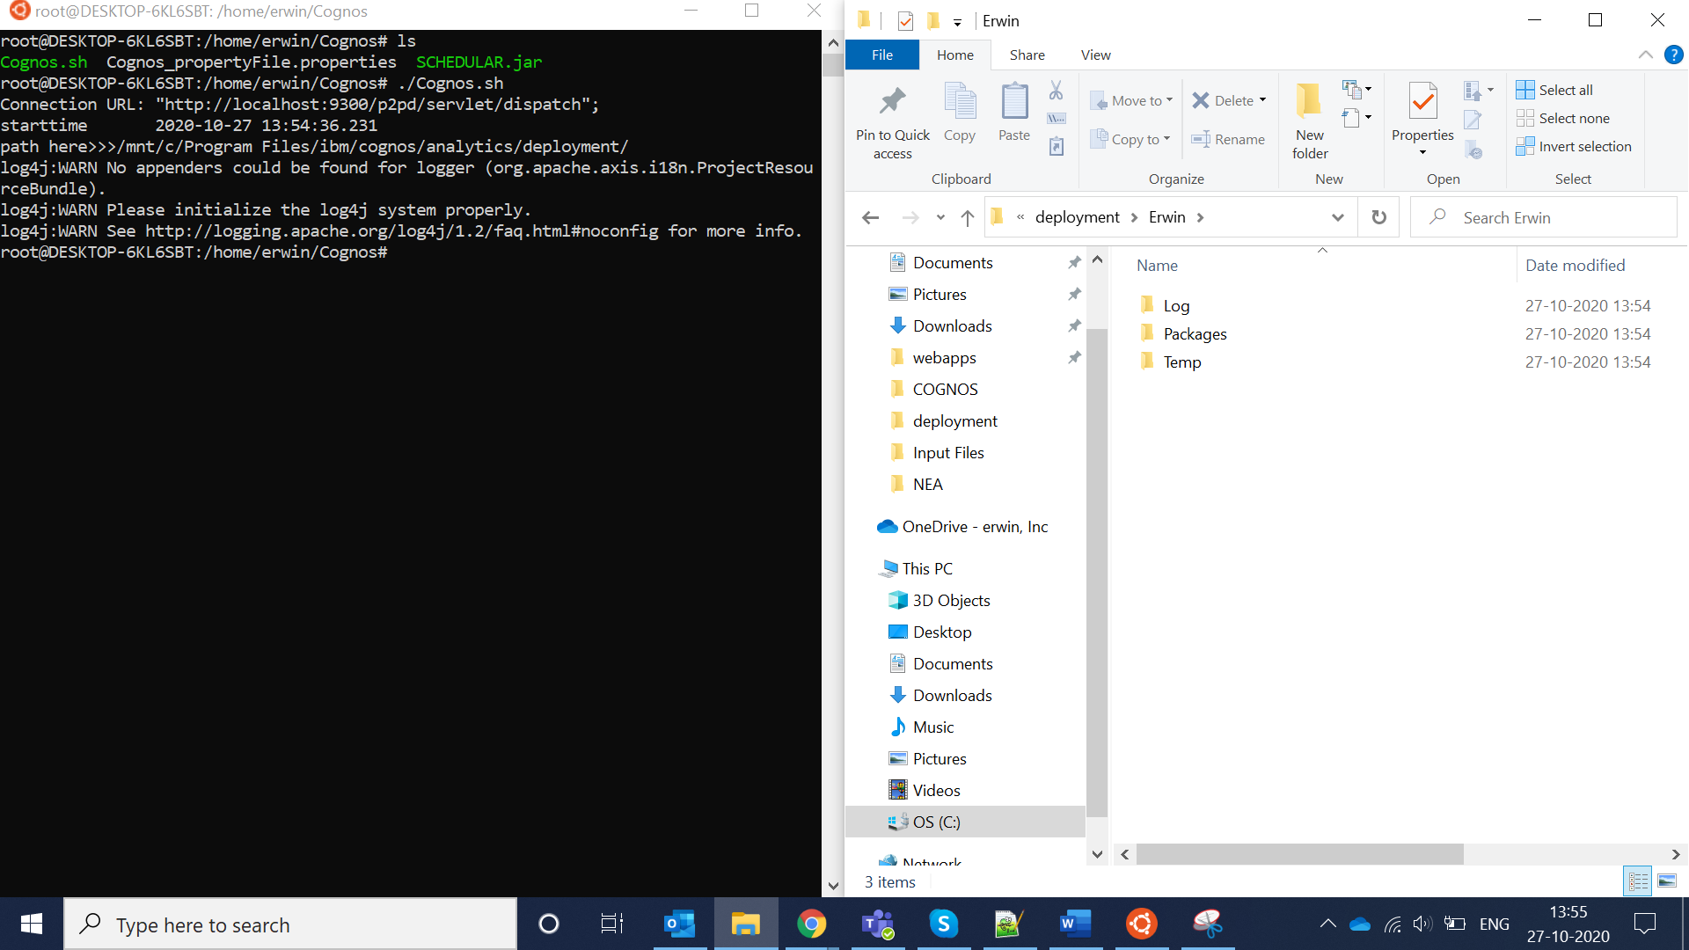

Log ->This will give the complete log information of Successful and Failed Reports from package directory.

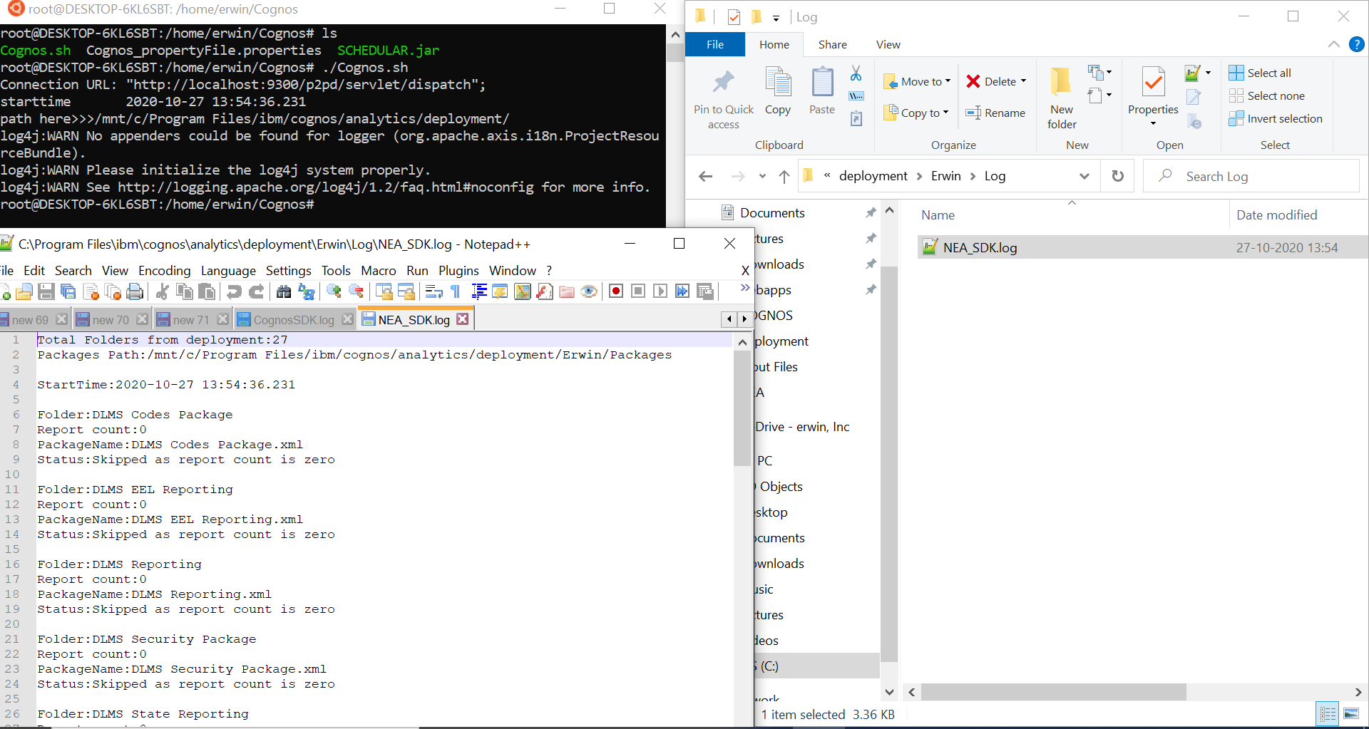

Package ->All Successful Packages are exported here.

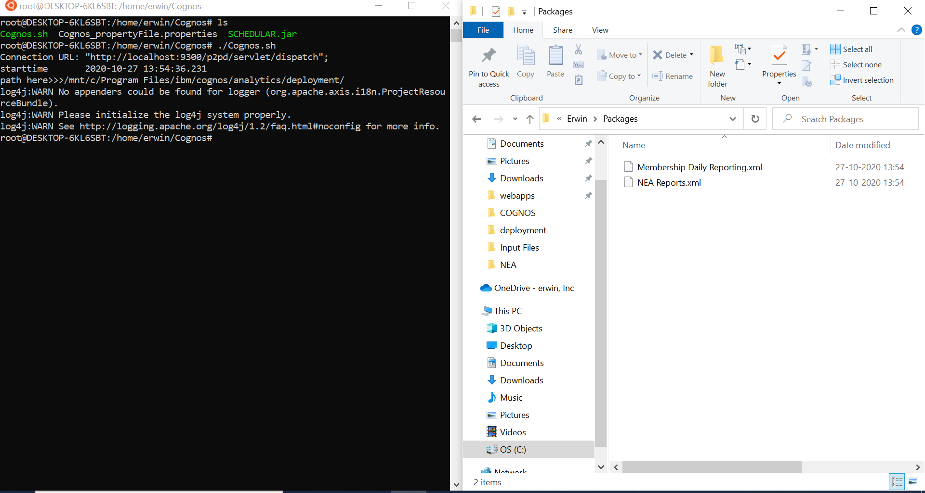

Temp-> This will have the complete export folder here, whether its bulk export or custom export with timestamp.

